Seethalakshmi Achi College For Women

Pallathur

Affiliated By Alagappa University

Department of Commerce

III -B.COM

**FINANCE AND ACCOUNTING WITH ZOHO BOOKS**

**Techpro Solutions**

**Team members**

1.S.Karthika( Team leader)

2.S.kavitha

3.M.Maha

4.S.Meenambigai

**Overview :**

Zoho Books is an accounting solution that is designed to help small business manage their finances. This solution includes dashboards and a wide variety of reports. Business users can automate tasks and set up custom workflows.

The vendor offers a 14 day free trial.

Zoho Books is online accounting software that manages your finances, keeps you GST compliant, automates business workflows, and helps you work collectively across departments.

Zoho Books is a smart accounting system designed for growing Businesses. It is very simple, easy to use, and able to help you make intelligent data-based decisions. It is also the pioneer accounting product of a reputed software provider, which eliminates all worries related to uptime, support, or security.

With Zoho Books, you can send professional invoices to customers and begin receiving online payments from them all from a single platform. It’s fast, powerful, and convenient, and helps regain control over the company’s Finances and save more in the future. For this purpose, you can rely on features such as cash flow statements, P&L, Balance sheet, and many more. As it is small-biz and mid-market-friendly, Zoho Books is relatively painless to afford.

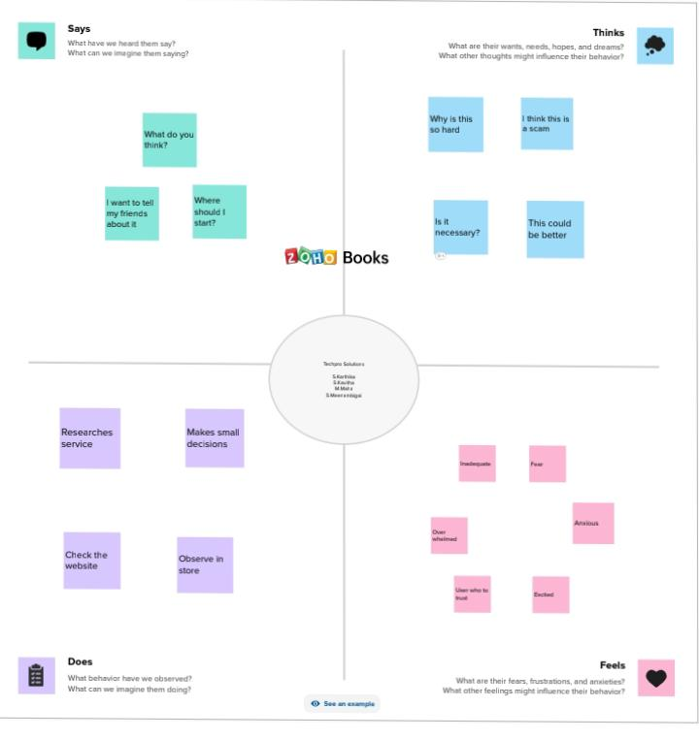**Empathy map**

**Brainstorming and Idea Prioritation**

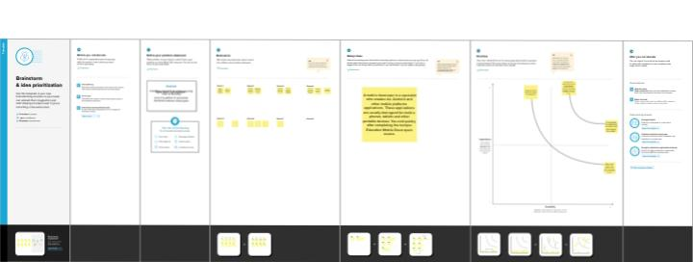

**Result:**

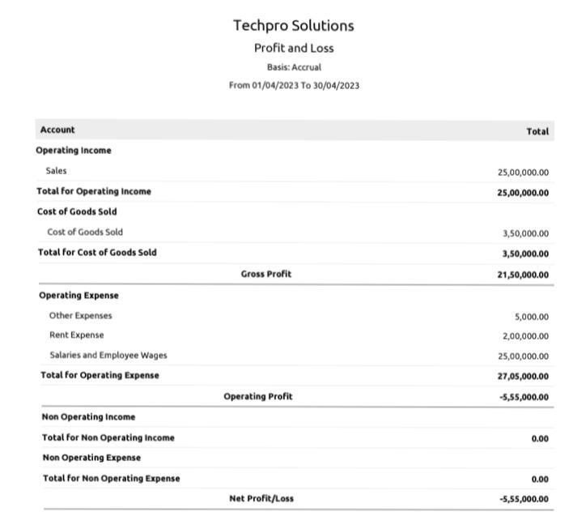

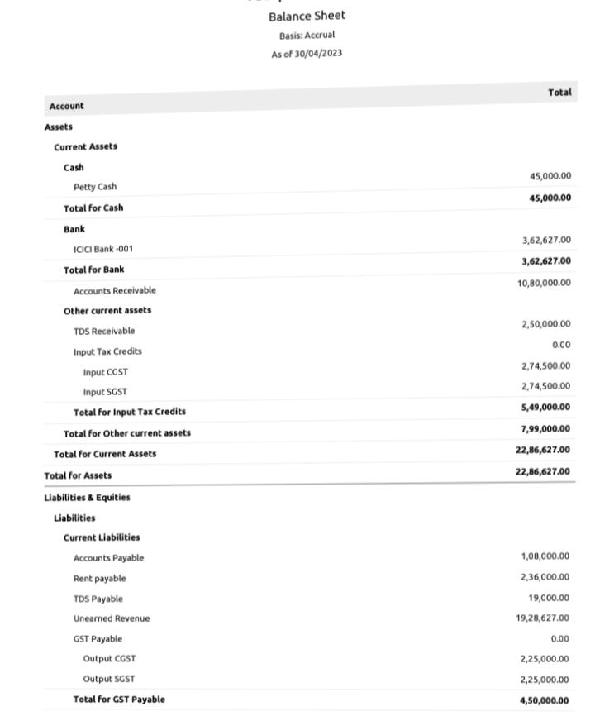

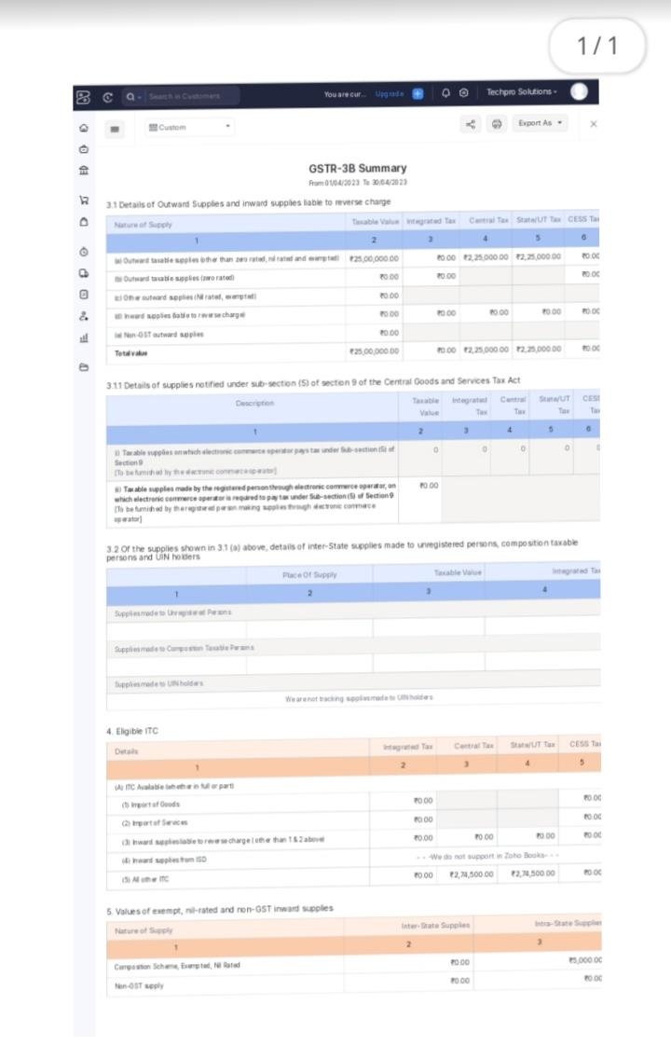

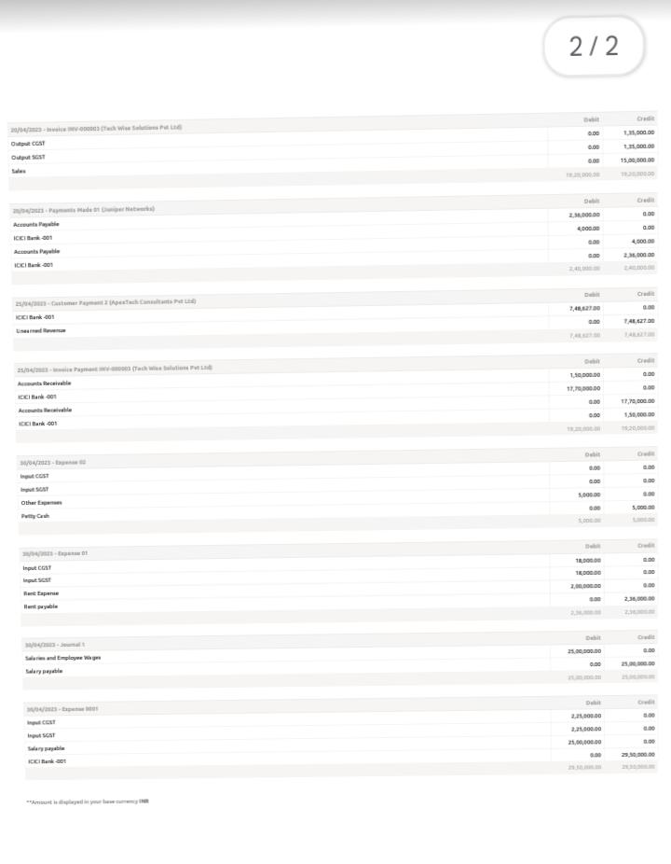

**Advantages of the proposed solution**

* Invoicing and Billing.
* Online payment.
* Expenses Tracking.
* Project Management & Timesheets
* Inventory Management
* VAT Tax Compliance
* Report Generation
* Reduce Overall Costs

**Disadvantages of the proposed solution:**

* Monthly transaction cap. One significant Zoho Books limitation is the Cap on monthly transaction
* Multiple Subscriptions for multiple businesses
* Additional users require a fee.
* Fewer integrations than competitors.
* No payroll services.
* Accounts payable limitations.

**The areas where this solution can be applied:**

Zoho Creator’s education ERP system has everything you need to completely run an educational institutions, from preschool all the way up to university. A custom school ERP built atop Creator’s intuitive low-code application development platform is a one-stop shop for all your education management needs.

From admissions to accounting, take care of everything with cloud-based applications. Build apps with minimal coding, or install prebuilt ones and customize them as needed

Contact Management. Online payments. Inventory Management. Expenses. Mobile apps.

Collaborative customer portal. GST Compliant accounting. Project Time Tracking.

Invoice Templates. Automatic Bank Feeds. Exhaustive Reports. Accounting

**Conclusions:**

Zoho Books not only helps streamline our invoicing, expenses and other business needs, but also simplifies Accounting needs to a great extent. One can even file GST returns from within it, which is a great add-on feature for free. Above all, the support is outstanding.

**Future Scope;**

Zoho Books now support recurring payments through stripe. You can receive recurring payments from your customers with payment card issued in India by either Visa or MasterCard. However, your customers’ card details will be saved only if they choose to save their cards while making payments